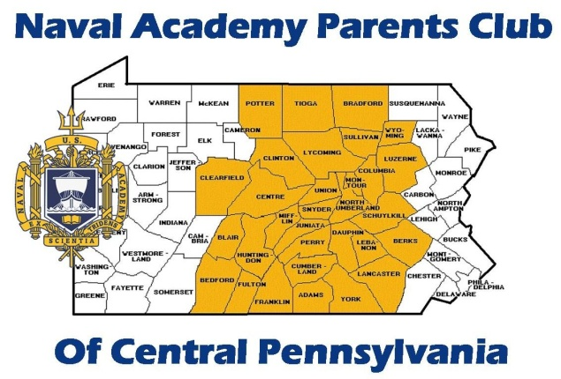

Class of 2022 Welcome Aboard Picnic

June 24, 2018
1:00 pm

The Forrester’s
225 Kreidler Avenue
York, PA

Hail & Farewell Celebrations are a military tradition most often associated with an arrival to or departure from a duty station. The Parents Club of Central PA would like to “hail” the Appointees and welcome their families at a Picnic in their honor. The Club will provide the main dish and drinks. Current Club members can sign up to bring sides and desserts on http://www.signupgenius.com/go/10C0D48A4AF2FA75-class
Appointees and their families are guests of the Club

This is a great opportunity to meet other appointees from the area and their families, gain valuable information from current Club members and Midshipmen. In addition, a few members from the USNA class of 1972 that live in our area will be in attendance. They are part of “Another Link in the Chain,” a program designed to provide mentors and resources to your Mids from Alumni who are 50 years ahead of them on this journey.

RSVP by June 15, 2018
margaretphillips@comcast.net

