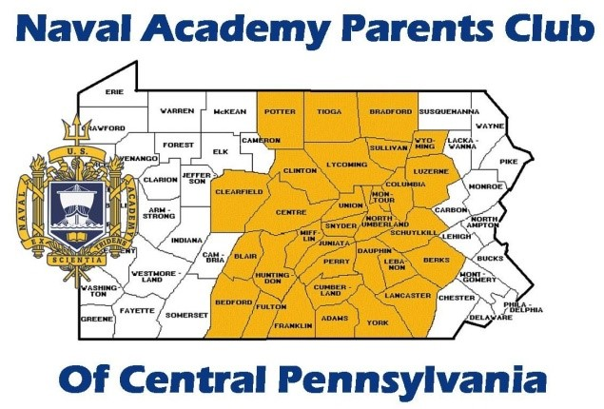
UNITED STATES NAVAL ACADEMY
PARENTS’ CLUB OF CENTRAL PENNSYLVANIA

The United States Naval Academy Parents’ Club of Central Pennsylvania is sponsoring a bus trip the United States Naval Academy in Annapolis, Maryland on Saturday March 26, 2022. The purpose of this trip is to give interested students and their parents an opportunity to see the Naval Academy first hand, learn about the application/appointment process, and meet with local area high school graduates who are presently midshipmen at the Academy.
The cost of $85.00 per person includes coach bus transportation to and from the Academy; a presentation by a USNA Admissions Officer; a question and answer session with Midshipmen, parents, and guests; lunch in Dahlgren Hall; a guided tour of the Academy grounds and buildings to include classrooms and typical living areas; and a stop at the gift shop. The coach bus will be boarded in Harrisburg and York. Reservations are limited and must be confirmed with payment. It is advisable to make reservations early. Seating on the bus will be on a first-come, first-serve basis.
Please make checks payable to “USNA Parents’ Club of Central PA”. To confirm your reservation, send your payment to: Nathan Lightner, 865 Sharon Ave. South, Red Lion, PA 17356. Please include your phone number and email address. We will update the trip status should anything change due to Covid-19 concerns or restrictions.

Call Evan Forrester at 717-873-3225 or email at evforrester@gmail.com for additional information and questions. This is the 28th year we have provided this service and the feedback received from participants from past trips has been very favorable. Students who are interested in attending the U.S. Naval Academy and their parents may wish to register for the trip.

